AGRICULTURAL ACT OF 2014, Fact sheet

Dairy MPP – Strategies for MY Farm
Curtis Mahnken, Center for Farm Financial Management, Applied Economics, August 2015
Agricultural Business Management
Kevin Klair, Center for Farm Financial Management, Applied Economics
Agricultural Business Management
Robert Craven, Center for Farm Financial Management, Applied Economics
Betty Berning, Agricultural Business Management, University of Minnesota Extension

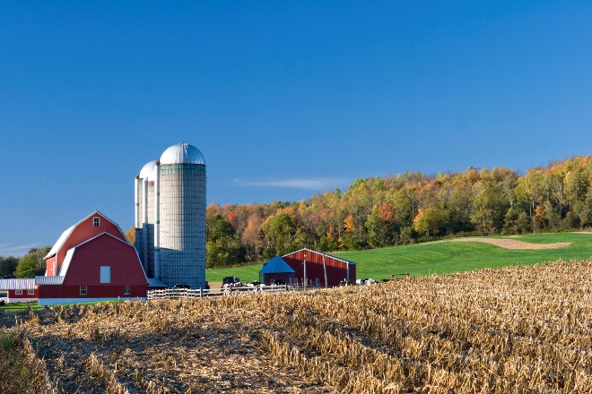
Dairy Margin Protection Program (MPP) 2016 enrollment opened July 1, 2015 and runs until September 30, 2015. MPP allows producers to protect milk price/feed cost margin by selecting a coverage level from $4.00 to $8.00/cwt. Dairy producers already enrolled in MPP must re-enroll for 2016. For producers that haven’t enrolled before, they must decide whether or not to sign up for the program. Once enrolled, producers are required to pay the $100 administrative fee annually, regardless of coverage level.

WHAT DO I NEED TO DO TO RE-ENROLL?
Producers need to visit their local FSA office to re-enroll. In addition, coverage level will need to be chosen. If you enrolled in MPP in 2015, you will receive a 2.61% “bump” on your production history.

should i sign up?
If you haven’t enrolled before, you’ll want to consider if MPP is for you. If you are currently not using a risk management tool, MPP is a good risk management option. If you’ve used LGM-Dairy as a risk management tool, and you choose to enroll in MPP your contracts will need to end by December 31, 2015.

how much milk should i protect?
This decision should be answered by considering the following: What is your current risk management strategy and what tools are you using? What percentage of your production is currently protected? Utilize MPP to cover the remaining portion of unprotected production.

What coverage level should i choose?
The best way to determine how the program will benefit your operation is to run several scenarios using the national MPP online decision tool available at www.fsa.usda.gov.
The tool is easy to use. Enter your annual production history and it will project the likelihood of receiving a payment based on current futures prices for both milk and feed.
If producers want to simplify the number of scenarios they consider, the University of Minnesota Extension Agricultural Business Management team suggests evaluating three options:
- Only Catastrophic
- Risk Management
- Maximize Predicted Net Return
The MPP decision tool was used to evaluate these strategies using two example farms. One sample farm had 4 million pounds of annual production (4M). The other had 20 million pounds (20M). In both examples, 90 percent of production was covered by MPP.
#1: Only Catastrophic
The first strategy--choosing $4.00 catastrophic coverage every year--resulted in payments only in 2009 and 2012. From 2009 to 2014, both example herds would have averaged a $0.10/cwt/year payment. This strategy does not offer much protection, but the cost is very low with just the $100 per year administration fee.
#2: Risk Management
The second strategy is a risk management strategy and provides strong coverage at a low cost. Premiums jump significantly past the $6.50 coverage level shown in figure 1.
Fig.1: MPP Premium Rates

Enrolling at $6.50/cwt every year, payments would have been received in 2009, 2012 and 2013. In 2010, 2011, and 2014 premiums would have been paid without receiving a payment. This resulted in a $0.54/cwt/year average payment for the 4M pound herd and $0.40/cwt/year for the 20M pound herd. Although this strategy doesn’t maximize payments, it does manage risk by covering the income gap in low margin years. This can be seen in figure 2 (provided by the National Milk Producers Federation).
Fig. 2: 2009 Dairy Production Margin
#3: Maximize Predicted Net Return
The third strategy uses the decision tool to select the coverage level each year that predicts the highest net return. The decision tool predicted buying $8.00 coverage from 2009 to 2014 for the 4M pound herd. The tool predicted average net returns at $0.62/cwt/year, but actual net returns would have been $0.81/cwt/year. This strategy would have resulted in the highest returns, but does require more analysis of the decision tool projections.
For the 20M pound herd, the tool projected choosing catastrophic coverage in 2010 and 2014, selecting $8.00 coverage in 2011, and selecting $6.50 coverage in 2009, 2012 and 2013. The predicted return from this strategy was $0.25/cwt/year, but the actual return would have been $0.34/cwt/year.
Results for all three strategies are provided in figure 3. The highest return for a 4M pound herd occurs when using the third strategy- selecting the highest predicted payments for each year. For the 20M pound herd, the risk management strategy, $6.50 coverage every year, results in the highest net returns.

Fig. 3: Net Returns for MPP Strategies
Regardless of the strategy, it’s important to figure out your feed margin, which can be used to calculate your MPP coverage needs. MPP is calculated after feed has been paid, which means that it is protecting what is left to pay non-feed costs. In order to maximize your protection while minimizing your MPP costs, calculate your feed margin to figure out your MPP coverage.
To calculate your feed margin, subtract your feed cost from your milk price. Subtract the national MPP margin from your feed margin to get your adjustment. This is the amount over/under the national margin that is available to pay non-feed costs. Subtract this adjustment from your non-feed costs to arrive at the MPP coverage level needed. Note: this calculation covers 100% of your production. However, MPP covers a max of 90% so you’ll need to divide this by .9 (90%) to calculate the coverage level needed to cover all of your non-feed costs. The values, presented in table 1, were calculated from FINBIN data.
Table 1: MPP vs MN Margin.
Milk/cwt | $19.19
- Feed/cwt | 9.12
= Feed margin | 10.07
- MPP Margin | 7.91
= MN adj. | 2.16
Non-ffed/cwt | 8.26
- MN adj. | 2.16
Mpp level needed 100% | 6.10
MPP Level needed 90% | 6.78
#Farms-finbin | 2,745

final thoughts
MPP is a risk management tool designed to provide protection for years like 2009. In years with high margins there will not be a payment, but overall MPP provides protection will help dairy farms minimize losses and stay in business.
Remember: MPP is a yearly decision, so you can change your strategy each year.
Important points to remember:
- MPP is a yearly decision. Coverage changes can be made each year.
- Know your feed margin
- Know your farm’s financial health and compare your farm to other MN dairies in FINBIN (FINBIN.umn.edu)
Useful Links
- MPP Online training is available at farmbill.umn.edu
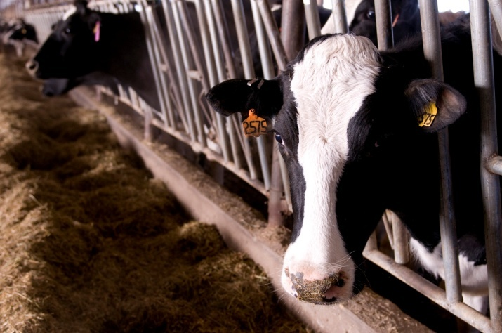
- MPP Dairy Decision Tool: www.fsa.usda.gov
- UMN Extension Agricultural Business Management: z.umn.edu/DairyFarmBill
- Dairy Markets and Policy: www.dairymarkets.org
© 2012, Regents of the University of Minnesota. University of Minnesota Extension is an equal opportunity educator and employer. In accordance with the Americans with Disabilities Act, this publication/material is available in alternative formats upon request. Direct requests to the Extension Store at 800-876-8636. Printed on recycled and recyclable paper with at least 10 percent postconsumer waste material.

